DRAG AND DROP

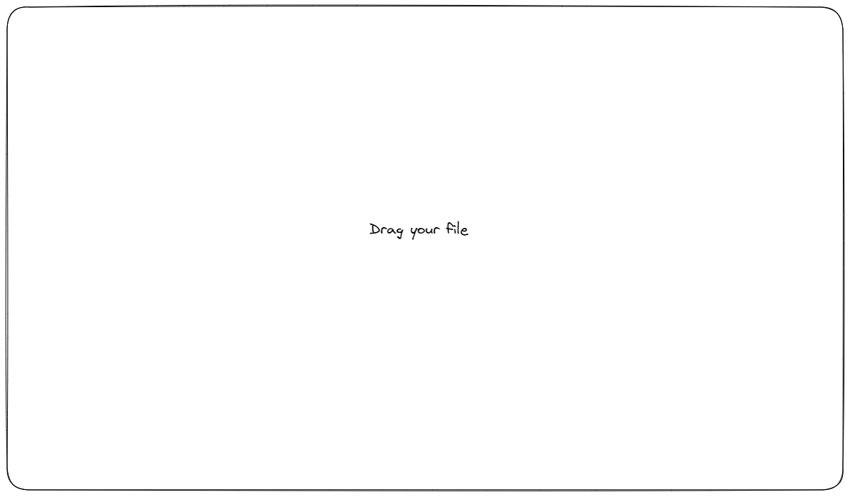

create the display where the user needs to drag and drop the file to upload it, once its loaded it goes to the next view

* search up how to create a drag and drop box using react
* implement the drag and drop view using react
* style the webpage using bootstrap

FORMATTING DISPLAY

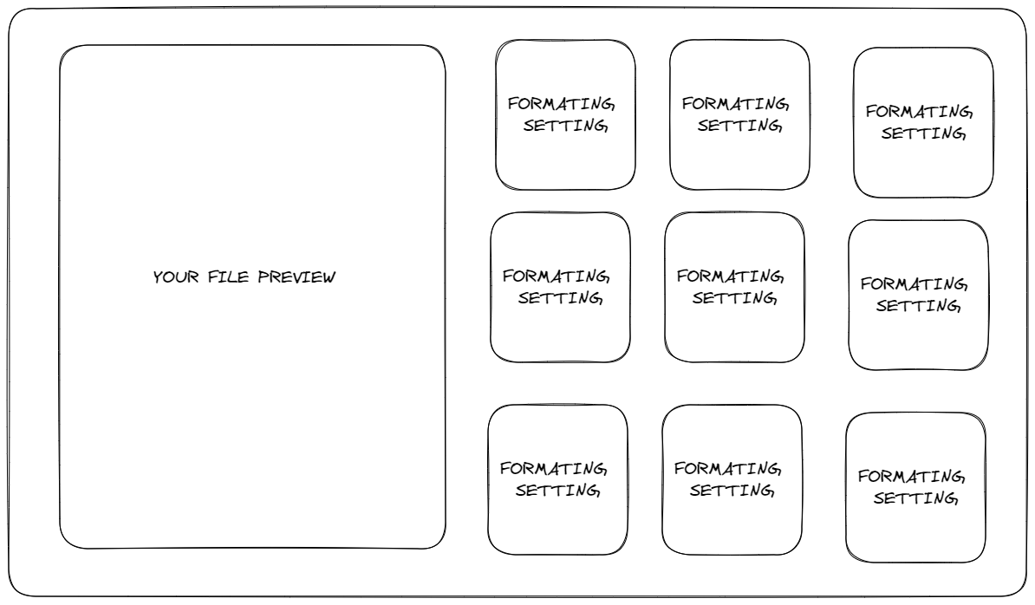

using react create the previous view, were you have a rectangle component displaying the file DEFAULT preview of the csv file that the user uploaded before and other smaller components that when they are clicked the alter the file preview component display to fit the formatting setting of the csv file

* create the layout of div components in react
* set up the default formatting setting to follow this criteria :

Column header 1 :Column header 1 field 1

Column header 2 : Column header 2 field 1

Column header 3 :Column header 3 field 1

BREAK

Column header 1 :Column header 1 field 2

Column header 2 : Column header 2 field 2

Column header 3 :Column header 3 field 2

BREAK

etc..

* set up another formatting component to follow this criteria :

Column header 1 : Column header 1 field 1

Column header 1 field 2

Column header 1 field 3

Column header 1 field 4

DOWNLOAD VIEW

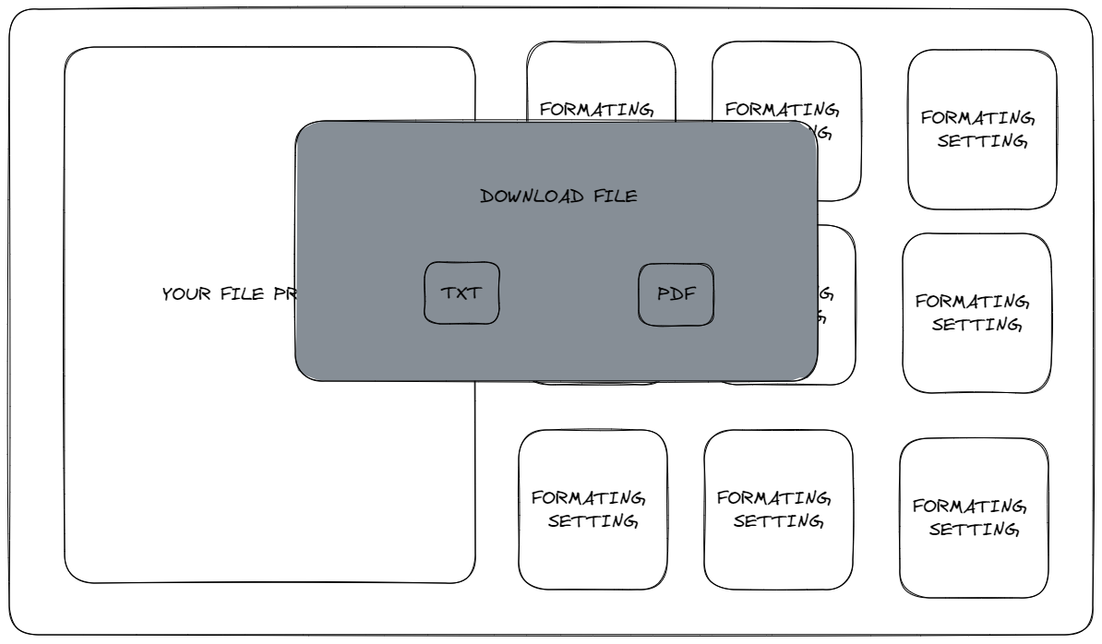

Create a download file pop up view when the client clicks on the your file preview component, the pop up is highlighted and displays 3 buttons, back, TXT and PDF,

the back button brings the client back, the TXT buttons downloads the file in a TXT format, and the PDF button downloads the file as a PDF

* Research how to create a component that pops up on the main view in react
* add the back button to go back to the previous view
* add a txt and pdf button to download the formatted file as previewed in the previous view